Manual Testing:--

MANUAL TESTING is a process, in which all the phases of STLC (SOFTWARE TESTING LIFE CYCLE) like Test planning, Test development, Test execution, Result analysis, Bug tracking and Reporting are accomplished successfully and manually with Human efforts. (or)

Testers manually execute test cases without using any automation tools. Manual testing is the most primitive of all testing types and helps find bugs in the software system.
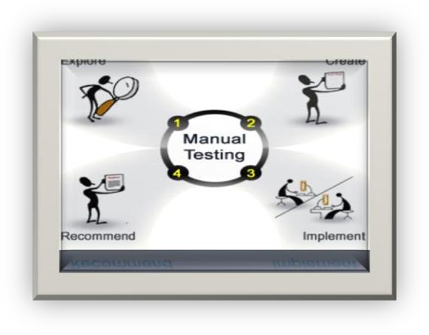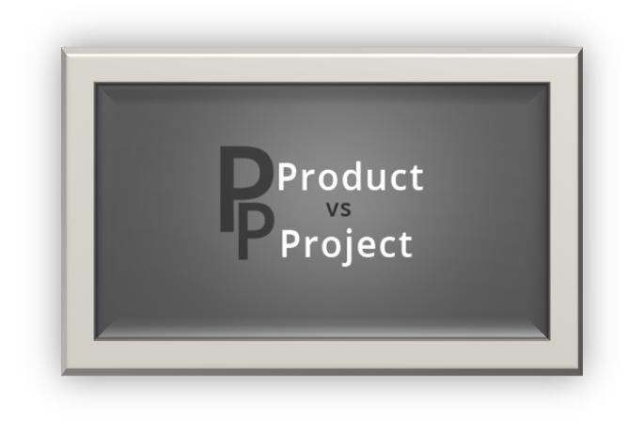
Manual Testing

Quality: Quality is defined as justification of all the requirements of a customer in a product / Project. (Or) Quality is defined as not only the justification of all the requirements but also the presence of the value (User friendliness).

Note: Quality is not defined in the product. It is defined in the customer`s mind


.
Defect: Defect is defined as a deviation from the Requirements;

Testing:

Testing is a process in which are identified defects, isolated, subjected for rectification and ensure that the product is defect free, in order to produce the quality product and hence the customer satisfaction. (or) Verification & Validation of software is called Testing.
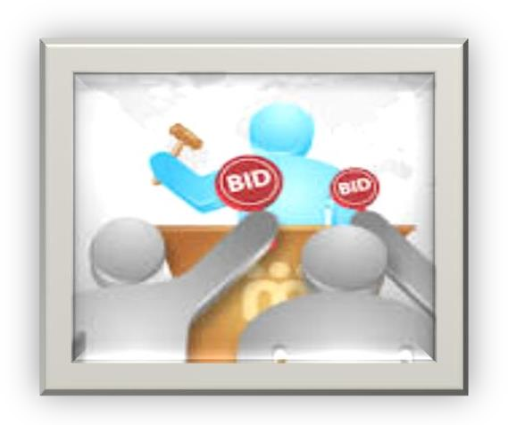
Testing
Bidding

Software Development Life Cycle (SDLC):

There are six phases in software development life cycle

- Initial (or) Requirements phase
- Analysis phase
- Design phase
- Coding phase
- Testing phase
- Delivery and Maintenance phase

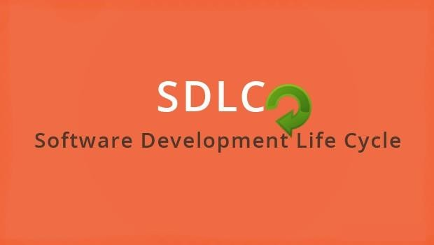

- Initial (or) Requirement phase:
Tasks: Interacting with customer and gathering the requirements. Prepare the FRS document.
Roles: Business analyst –BA/FP (Functional People), Engagement manager - EM
Process:
  - BA will analyze the requirements first, if at all any doubts on the requirements, he will list out all the doubt in RCN (Requirement Clarification Note)

  - First of all business analyst will take an appointment from the customer, collect the template (RCN) for the company and meet the customer on appointed date, gather the requirements with the support of that template and come back to the company with the new requirement document .

  - The engagement manager go through the requirements ,if he find any extra requirements then he will deal with excess cost of the project.

  - If at all he finds any confused requirements, then he will ask the concern team to build a prototype, demonstrate that prototype to the customer, gather’s the clear requirements and finally hand over the required documents to the BA

  - Based on the customer requirements BA people will develop FRS document.

Proof:
The proof document of Initial phase is Requirement’s Document (RD). These documents are called different Names in different companies:
FRS: Functional Requirement Specifications
CRS: Customer (or) Client Requirement Specifications
URS: User Requirement Specifications
BRS: Business Requirement specifications
BDD: Business Design Document
BD: Business Document

Some companies will maintain two documents. One is for overall business flow information and second is detailed functional information, but some companies will maintain both this information’s in a single document

ANALYSIS PHASE:
TASKS:
  - Feasibility study
  - Tentative planning
  - Technology selection and Environment confirmation
  - Requirement analysis
Roles:
System Analyst – SA, project Manager – PM, Technical Manager - TM

Process:
- Feasibility study:
It is detailed study conducted on the requirement documents, in order to confirm whether the given requirements are possible within the given budget, time and available resources or not.

- Tentative planning: In this section resource planning and time planning will be temporarily done.
- Technology selection & Environment confirmation:
The list of all technologies required for accomplishing the project successfully will be analyzed the environment suitable for that project will be selected and mentioned here in this section.

- Requirement analysis:
The list of all the requirements that are required by the company to accomplish this project successfully
will be analyzed and listed out clearly in this section.

Note: Requirements may be Human Resources, Software’s, and Hardware’s.
Proof: The proof document of the Analysis phase is System Requirements Specifications (SRS)/Project plan.

DESIGN PHASE:
Tasks: High level designing and Low level designing
Roles: High level design is done by chief Architect(CA) and Low level design is done by Technical Lead(TL) Process:
  - The chief architect will divide the whole project in to modules by drawing some diagrams using unified modeling language (UML).

  - The Team lead will divide the modules into sub modules by drawing some diagrams using the same UML.

  - In this phase they will also design GUI part of the application, as well as PSEUDO CODE also developed

Proof:
The proof document of this phase is Technical Design Document (TDD).

LLD: Ex: DFD-Data Flow Diagram, E-R Diagram, Class Diagram, Object Diagram.

PSEUDO CODE: PSEUDO Code is a set of English instructions, which will make the developer’s more comfortable, while developing the actual source code
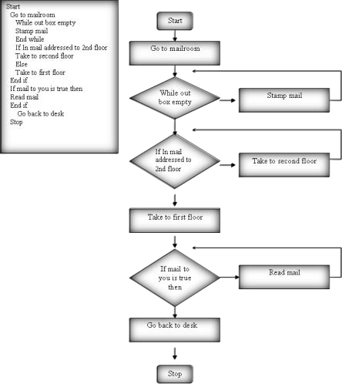

- CODING PHASE: (WHITE BOX TESTING) Tasks: Programming (or) Coding
Roles: Programmers (or) Developers
Process: The developers will develop the actual source code by following the coding standards and also with the support of Technical Design Document(TDD).

Example’s for Coding standards:
  - Proper Indentation (left margin)
  - Color codling’s
  - Proper Commenting

Proof: Proof document of the Coding phase is Source Code Document (SCD).

V TESTING PHASE: (BLACK BOX TESTING)
Tasks: Testing
Roles: Test Engineer’s.
Process:
- The Testing department will receive the requirement document (FRS) and the test engineers will start understanding the requirements.

- While understanding the requirements, if they get any doubts they will list out all the doubts in Requirement Review Report (RRR) and sent it to the author of the requirement document and wait for the clarification.

- Once the clarification is given and after understanding all the requirements clearly (FRS/CR is the Baseline) they (QA Engg) will take the test case template (Common Repository) and write the Test cases then will send this document to Team Lead for verification. Test Case document will be based lined (Final document…No modifications).

- TL will store this TC’s doc to server, PM Review / Client Review, once we got approval from PM and Client, then permanently will store it to an server(shared repository, Eg: Wiki, MS share point,…)

- Once the first build is released from dev team they(QA) will execute the test cases.

Logged into the Bug tracking tool) and send it to the development department and will wait for the next build.

- Once the next build is released they will re execute the required test cases.
- If at all any more defects are found they will update the defect profile. Send it to development department and will wait for the next build.

- This Process continuous till the product/Project is defect free.

Proof:
The proof of Testing phase is Quality product/Project.

DELIVERY AND MAINTENANCE PHASE:
Delivery:
Tasks: Hand over the Application to the client
Roles: Deployment engineers (or) Installation engineers.
Process: The Deployment engineers will go to the customers place, install the application in to the customers environment and handover the original software to the client.

Proof: The final official agreement made between the customer and company is proof document for Delivery.
Maintenance: Once the application is delivered. The customer will start using it, while using if at all they face any problems then that particular problem will be created as tasks. Based on the tasks corresponding roles will be appointed. They will define the process and solves the problem .This process is known as Normal Maintenance. But some customers may request for continuous Maintenance, in that case a team of members will be continuously working in the client site in order to take care of their Software

Testing methodology:

Basically there are 2 methods of Testing:
  - Black Box Testing
  - White Box Testing
  - Gray box testing

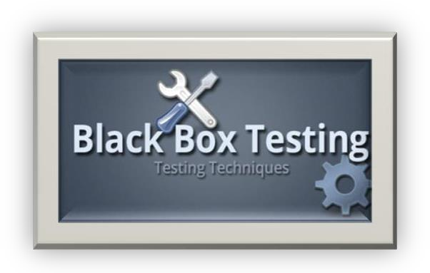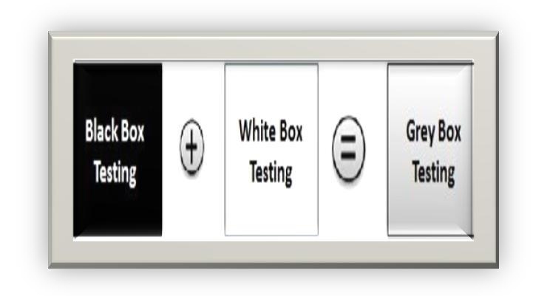

BLACK BOX TESTING:

- It is method of testing in which one will perform testing only on the functional part of the application without having the knowledge of structural part.

- Usually the Black Box Test engineers (QA Engineer) will perform.

WHITE BOX (or) GLASS BOX (or) CLEAR BOX TESTING:

- It is a method of testing in which one will perform testing on the structural part of the application.

- Usually the White Box Tester’s or Developer’s will perform.

GREY BOX TESTING:

It is method of testing in which one will perform testing on both the functional part as well as structural part of the application.

- Usually the Test engineer’s who has the knowledge of structural part will perform.

LEVELS OF TESTING:

There are 5 levels of Testing:

- Unit level testing
- Module level testing
- Integration level testing
- System level testing
- User acceptance level testing

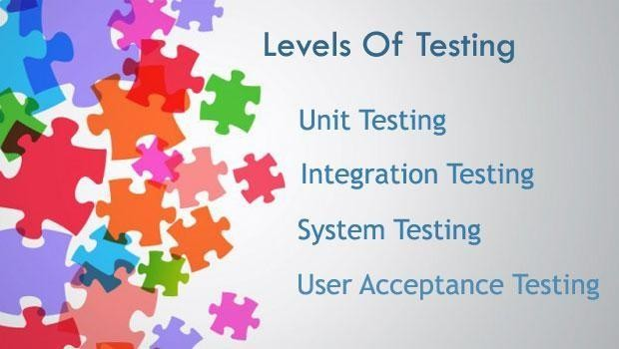

I.
UNIT LEVEL TESTING:
Unit: Unit is a smallest part of an application (Program). In this stage the white box testers will test each and every program and combinations of programs in order to confirm whether they are working according to the expectations or not. They test the structural part of a module.

MODULE LEVEL TESTING:
Module: Module is defined as a group of related features to perform a major task in an application. In this stage the Black Box test engineer’s will test the functional part of a module.

INTEGRATION LEVEL TESTING:

In this stage the developers will develop interfaces (Linking Prg’s), in order to integrate the modules .The White Box testers will test whether the interfaces are working fine or not.Developers will integrate the modules by following any one of the following approach:

SYSTEM LEVEL TESTING:
In this level the Black Box test engineers will conduct so many types of testing like load testing, performance testing, stress testing, compatibility testing, system integration testing etc.

SYSTEM INTEGRATION TESTING: It is a type of testing in which one will perform some actions at one module and check for the reflections in all the related areas.

Ex:
Warehouse
Finance
Inventory
Sales
Purchase

USER ACCEPTANCE TESTING:
In this stage the Black Box test engineers will test once again the user desired areas in the presence of the user in order to make him accept the application.

User acceptance testing, a testing methodology where the clients/end users involved in testing the product to validate the product against their requirements. It is performed at client location at developer’s site

It is two types

  - Alpha Testing..!!
  - Beta Testing..!!

Alpha testing takes place at the developer’s site by the internal teams, before release to external customers. This testing is performed without the involvement of the development teams.

Beta testing also known as user testing takes place at the end users site by the end users to validate the usability, functionality, compatibility, and reliability testing.

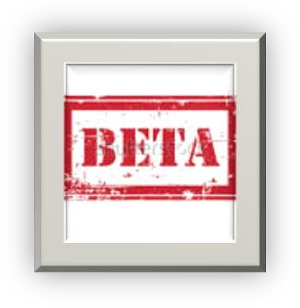

ENVIRONMENT:

Environment is defined as group of hardware components with some basic software’s which can hold the business logic, presentation logic and database logic. (or)

Environment is a combination of Presentation layer, Business layer, and Database layer which can hold presentation logic, business logic and database logic.

TYPES OF ENVIRONMENTS:

There are 4 types of environments:

    - STAND-ALONE ENVIRONMENT (OR) ONE-TIER ARCHITECTURE.
    - CLIENT-SERVER ENVIRONMENT (OR) TWO-TIER ARCHITECTURE.
    - WEB ENVIRONMENT (OR) THREE-TIER ARCHITECTURE.
    - DISTRIBUTED ENVIRONMENT (OR) N-TIER ARCHITECTURE.

STAND-ALONE ARCHITECTURE:
In this environment all the three layers that is presentation layer, business layer, database layer will be available in the single tier. When the application needs to be used by a single user at a time then one can suggest this environment.
PL
BL
DBL

Ex: Personal Computer.

CLIENT-SERVER ENVIRONMENT:
In this environment two tiers will be there. One is for clients, other is for servers. Presentation layer and business layer will be available in each and every client; database layer will be available in the server.

Whenever the application need to be used by multiple users sharing the common data in a single premises and wants to access the application very fastly and there is no problem with security. Then one can suggest client-server environment.

Ex: LAN(Local Area Network).

+

BL
PL
DBL

WEB ENVIRONMENT:

This environment contains three tiers. One is for clients, middle one is for application server and the last one is for database
servers.

Presentation layer will be available in client, Business layer will be available in the application server and Database layer will be available in the database servers.

Whenever the application needs to be used all over the world by limited number of people then this environment can be suggested.

Ex: WAN. + +
DBL
BL
PL

DISTRIBUTED ENVIRONMENT:
This environment is similar to web environment but number of application servers are introduced in individual tiers. In order to distribute the business logic, so that load will be distributed and performance will be increased.

Whenever the application needs to be used all over the world by huge number of people then this environment can be suggested.
BL | BL | BL
AS | AS | AS

Ex: yahoo.co.in, yahoo.co.uk, yahoo.co.us….etc. PL +
DBL

AS – APPLICATION SERVER BL – BUSSINESS LOGIC
DATABASE: It is a base (or) a place where one can store and retrieve the data
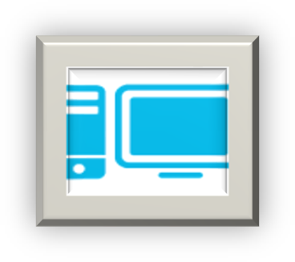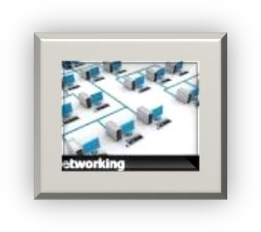
ONE TIRE
LAN
WAN

SOFTWARE PROCESS DEVELOPMENT MODELS:

        - WATER FALL MODEL
        - PROTOTYPE MODEL
        - EVOLUTIONARY MODEL
        - V-MODEL
        - AGILE MODEL

- WATERFALL MODEL:

PHASE ACTIVITY OUTCOME
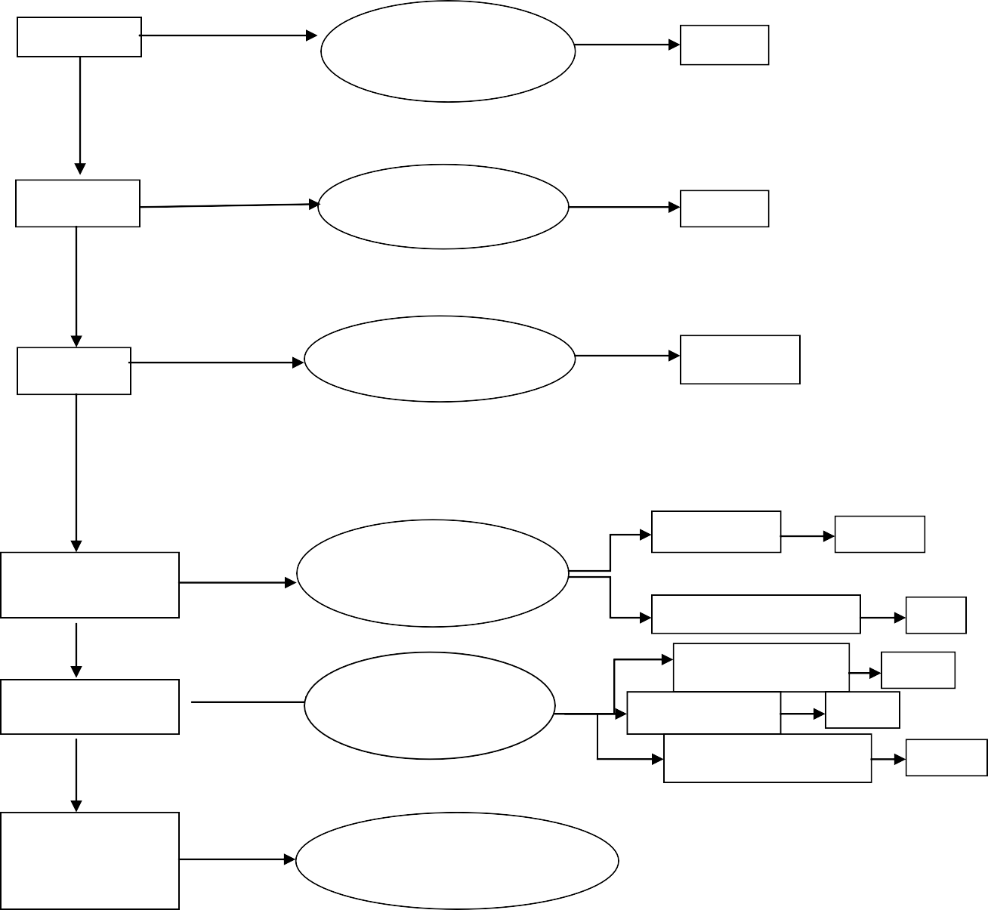
INITIAL
REQUIREMENTS
GATHERING
BRS
ANALYSIS
SYSTEM DESIGN
SRS
SOFTWAREDESIGN
DESIGN
TDD, GUI
UNIT TEST
IMPLEMENTATION
UTR
CODING
INTEGRATION TEST
ITR
MODULE TEST
MTR
TESTING
BLACK BOX
TESTING
SYSTEM TEST
STR
USER ACCEPT TEST
UATR
DELIVERY &
DELIVERY TO CLIENT
MAINTANANCE

ADVANTAGES:

  - It is a simple model.
  - Project monitoring and maintenance is very easy.

DISADVANTAGES: Can’t accept the new requirements in the middle of the process.

2. PROTOTYPE MODEL:

UNCLEAR REQUIREMENTS
SRS-DOC

BASE LINED
CLIENT ENVIRONMENT

CONNFIRMATION
H/W

PROTOTYPE
S/W

PROTOTYPE
DEMO TO CLIENT
PROTOTYPE
DEMO TO CLIENT
BRS-DOC

BASE LINED
REQUIREMENTS ARE

REFINED

ADVANTAGES:

Whenever the customer’s are not clear with their requirements then this is the best suitable model.

DISADVANTAGES:

    - It is not a full fledged process development model.
    - Prototype need to be build on companies cost.
    - Slightly time consuming model.
    - User may limit his requirements by sticking to the PROTOTYPE.

ENVIRONMENT MODEL:-

DEVELOPMENT AND TESTING
APPLICATION
INITIAL REQUIREMENTS

16
APPLICATION

BASE LINED
USER
FEED BACK WITH NEW

USER ACCEPT

ADVANTAGES: Whenever the customers are evolving the requirements then this is the best suitable model.
Adding the new requirements after some period of time.

DISADVANTAGES:

- Project monitoring and maintenance is difficult.
- Can’t define the deadlines properly.

VERIFICATION:
Verification is a process of checking each and every role in the organization in order to confirm weather they are working according to the company’s process guidelines or not.

VALIDATION:
Validation is a process of checking, conducted on the developed product / project or its related parts in order to confirm whether they are working according to the expectations or not.

VERIFICATION: Quality Control people (Reviews, Inspections, Audits, Walk through).
VALIDATION: Quality Assurance people (Testing).

6. V-MODEL:

Validation
Verification QC people
INITIAL
& ANALYSIS
BRS
SRS
PREPARING PROJECT PLAN
PREPARING TEST PLAN REQ.PHASE TESTING
DESIGN
& CODING
TDD
DESIGN PHASE TESTING
PROGRAM PHASE TING
SCD
SYSTEM TESTING
TESTING
S/W
TEST MANAGEMENT PROCESS
BUILD
USER ACCEPTANCE TESTING
DELIVER
& MAINTANANCE
PORT TEST
S/W EFFICIENCY
TEST S/W CHANGES (Enhancements)
Quality Product

“V” Represents Validation and Verification.

DRE=0-1(Range).

DRE=A/A+B
DRE = Defect Removal Efficiency.
A = Defects found by the Testing Team. .
B = Defects raised by the Customer.
DRE=80/80+20=80/100=4/5=0.8 (Good Software).

GOOD SOFTWARE 0.7-1 POOR SOFTWARE :Below 0.7

ADVANTAGES:
As verification, validation, test management process is maintained. The outcome will be a quality product

DISADVANTAGES:

- Time consuming model.
- Costly model.

AGILE MODEL: Before development of the application, where testers write the test cases and gives to the development team, so that it can be easy for developers to develop defect free Programs.

When to use Agile model:
When new changes are needed to be implemented. The freedom agile gives to change is very important. New changes can be implemented at very little cost because of the frequency of new increments that are produced.

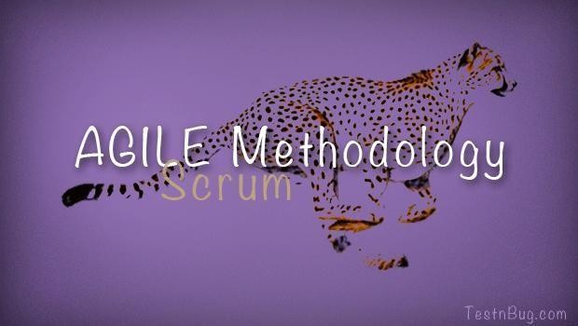

What Is Agile?
Agile methodology is an alternative to traditional project management, typically used in software development. It helps teams respond to unpredictability through incremental, iterative work cadences,
known as sprints. Agile methodologies are an alternative to waterfall, or traditional sequential development.

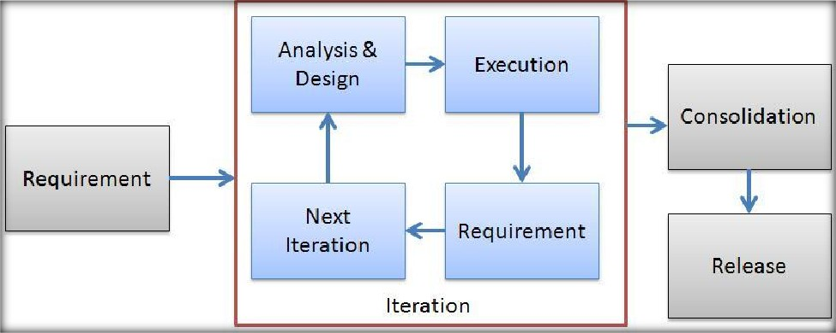

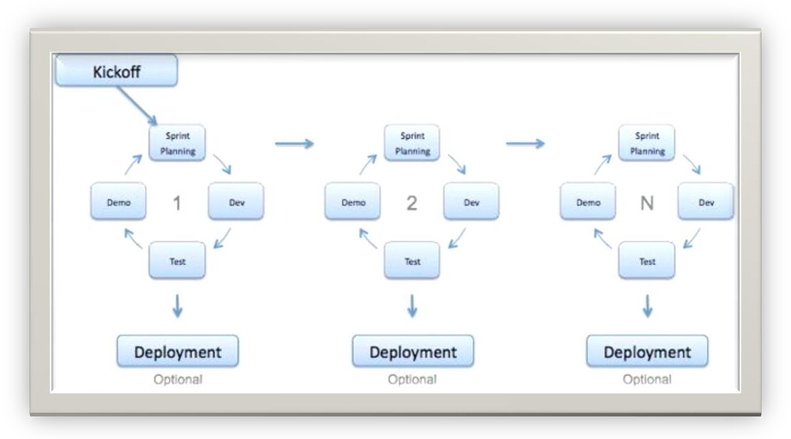

Advantages of Agile model:
- Working software is delivered frequently (weeks rather than months).
- Face-to-face conversation is the best form of communication.
- Close, daily cooperation between business people and developers.
- Continuous attention to technical excellence and good design.
- Regular version to changing conditions.
- Even late changes in requirements are welcomed
DisAdv
- In case of some software deliverables, especially the large ones, it is difficult to assess the effort required at the beginning of the software development life cycle.
- There is lack of emphasis on necessary designing and documentation.
- The project can easily get taken off track if the customer representative is not clear what final outcome that they want. Only senior programmers are capable of taking the kind of decisions required during the development process.

TYPES OF TESTINGS
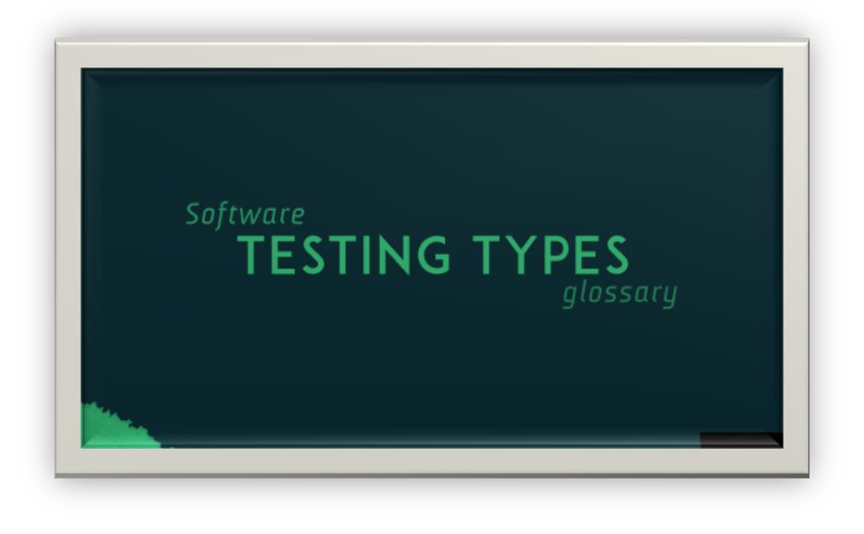

- BUILD ACCEPTANCE TEST/BUILD VERIFICATION TEST/SANITY TESTING/SMOKE TESTING:
It is type of testing In which one will perform overall testing on the released build, in order to confirm whether it is proper for conducting detailed testing or not.

Usually they check the following during this type of testing:

  - Whether the build is properly installed or not
  - Whether one can navigate to all the pages of application or not
  - Whether all the important functionality is available or not
  - Whether all the required connections(Hyper Links) are properly established or not

Some companies even called this as SMOKE TESTING, but some companies will say that before releasing the build to the testing department, the developers will check whether the build is proper (check the above 4 points) or not that is known as SMOKE TESTING, and once the build is released what ever the test engineers is checking is known as BAT or BVT or SAINITY TESTING (BAT: Build Acceptance Test, BVT: Build Verification Test).
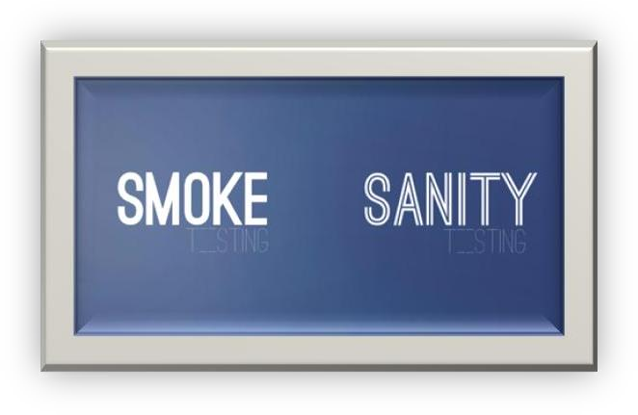

Sanity testing determines whether it is reasonable to proceed with further testing or not.Smoke testing consists of minimal attempts to operate the software, designed to determine whether there are any basic problems that will prevent it from working at all. Such tests can be used as build verification test.

REGRESSION TESTING:

It is type of testing in which one will perform testing on the already tested functionality again and again. Usually we do this in 2 scenarios:

  - Whenever the testers identify the defects raise to the developers, next build is released then the test engineers will check defect functionality as well as the related functionality once again.
  - Whenever some new features are added, the next build is released to testing department team. Then the test engineers will check all the related features of those new features once again this is known as Regression Testing

Note: Testing new features for the first time is known as New testing it not the Regression testing. Note: Regression testing starts from 2nd build and continuous up to last build.
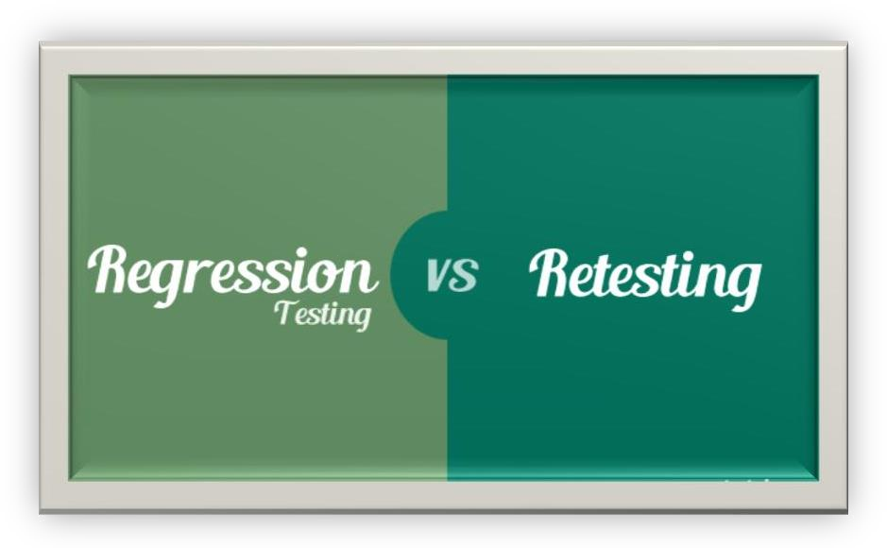

Regression testing is the process of testing already tested functionalities on the iterative builds Executing the passed test cases on the incremental or iterative builds is
also known as Regression testing

RETESTING:
It is type of testing in which one will perform testing on the same functionality again and again with deferent sets of values, in order to confirm whether it is working fine or not.

Note: Retesting starts from 1st build and continuous up to last build. Note: During Regression testing also Retesting will be conducted.
Retesting is to test the same functionalities again and again by using multiple sets of test data For ex: Testing gmail functionality by using 100 login credentials.Executing the failed test cases on the incremental or iterative builds is also known as Re testing

ALPHA TESTING:

It is type of user acceptance testing conducted in the software company by the test engineers just before delivering the application to the client.

BETA TESTING:

It is also a type of user acceptance testing conducted in the client’s place either by the end users or third party experts, just before actual implementation of the application.

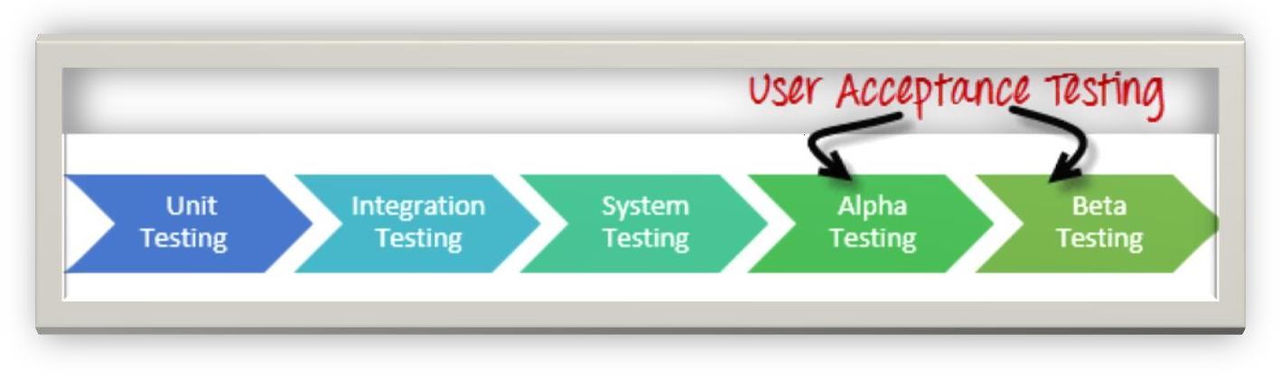
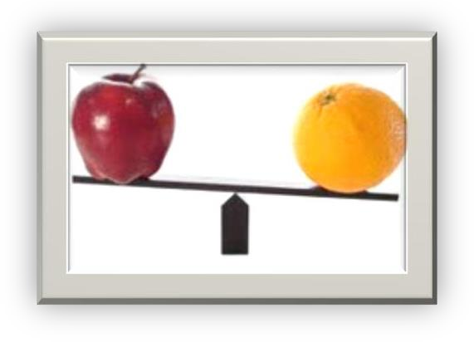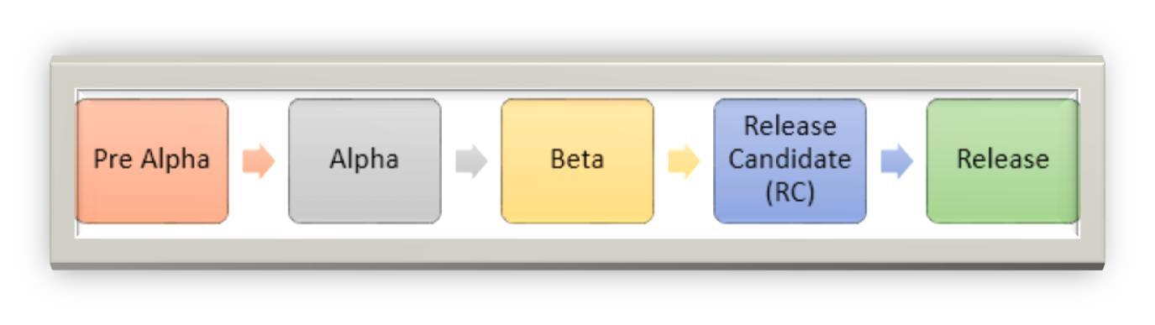

- STATIC TESTING: (Look and Feel Testing)

It is a type of testing in which one will perform testing on the application or its related factors without doing any actions.
EX: GUI Testing, Document Testing, Code Reviews etc…,

DYNAMIC TESTING:

It is a type of testing in which one will perform testing on the application or its related factors by doing some actions and find the defect is nothing but dynamic testing. Ex: Functional Testing

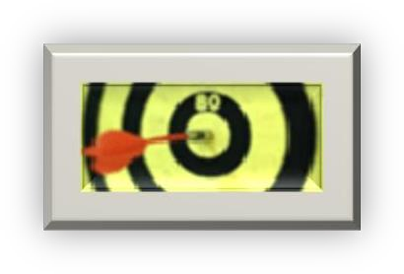
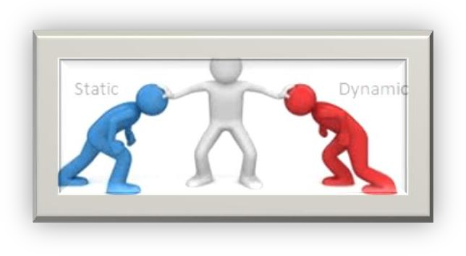

INSTALLATION TESTING:

It is a type of testing in which one will install the application in to the environment, following the guide lines provided in the deployment document(Installation Document), in order to confirm whether these guide lines are really suitable for installing the application into the environment or not.

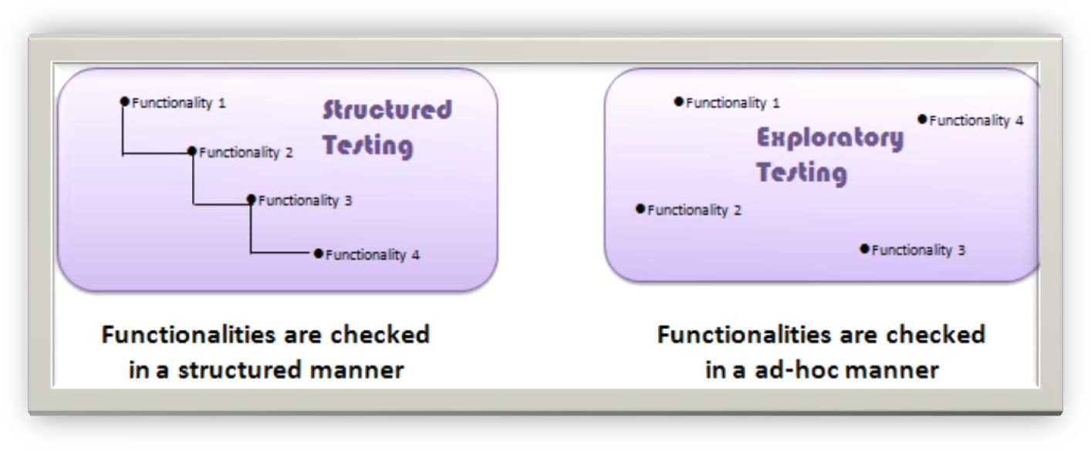

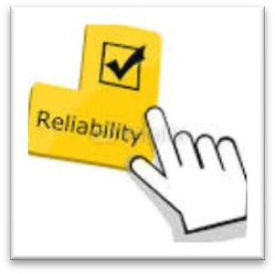
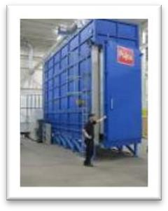
COMPATABILITY TESTING:

Testing the application in multiple browsers and operating systems (environments) and check whether the application is working as per expectations or not in all the environments is known as compatibility testing. Ex: Test the gmail.com on Firefox, IE, Google Chrome, Safari and opera in windows, Linux and Mac systems

EXPLORATORY TESTING:

EXPLORING: of about some Having basic knowledge concept, doing some thing and knowing more about the same concept is known as Exploring.

It is a type of testing in which the domain experts will perform testing on the application with out having the knowledge of requirements, just by parallel exploring the functionality.

END TO END TESTING:

It is a type of testing in which one will perform testing on the end to end scenarios of the application.

EX: Login---> Balance Enquiry ---> Withdraw ----> Balance Enquiry ---> Logout.

SOAK TESTING/ RELIABILITY TESTING:

It is a type of testing in which one will use the application continuously for a long period of time, in order to check the stability of the application.

AD-HOC TESTING:

It is a type of testing in which one will perform testing in their own style after understanding the requirements clearly.

Note: Usually in the final stages of the project, this type of Testing can be encouraged.

After understanding all the requirements of the application and one round of manual testing is completed then the test engineer will perform testing in user defined order is known as adhoc testing. By performing adhoc testing, the test engineer can provide the user friendliness to the application.

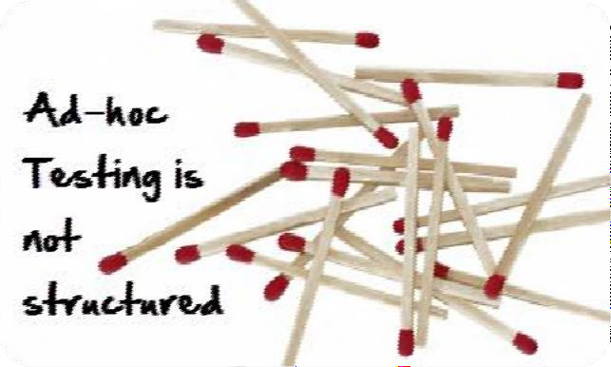

PERFORMANCE TESTING:
It is an advanced testing technique and expensive to apply because testing team have to create huge environment to conduct this testing. During this test, testing team validates Speed of Processing.

During this performance testing, testing team conduct load testing and stress testing.
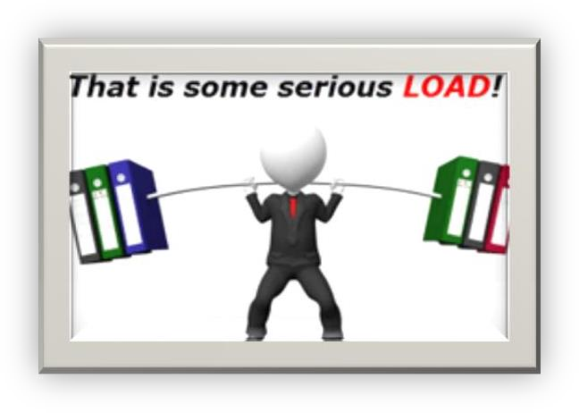

- GLOBALIZATION TESTING: Testing method that checks proper functionality of the product with any of the culture/locale settings using every type of international input possible. It is performed by the testing team.

- VOLUME TESTING: Testing which confirms that any values that may become large over time (such as accumulated counts, logs, and data files), can be accommodated by the program and will not cause the program to stop working or degrade its operation in any manner. It is usually conducted by the performance engineer.

SOFTWARE TESTING LIFE CYCLE (STLC):

STLC contains 6 phases:

  - Test Planning.
  - Test Development.
  - Test Execution.
  - Result Analysis.
  - Bug Tracking.
  - Report.

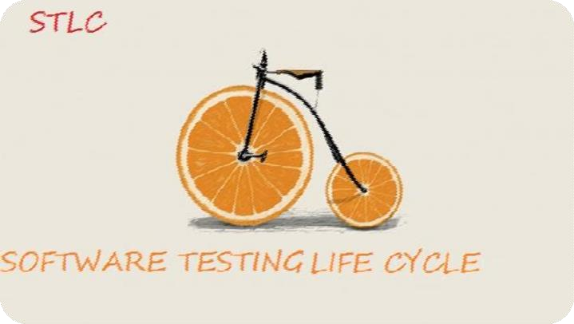

- Test planning:

Plan: Plan is strategic document which describes how to perform a task in an effective, efficient and optimized way.

Test plan: Test plan is strategic document, which contains some information that describes how to perform testing on an application in an effective, efficient and optimized way.

Optimization: It is process of utilizing the available resources to their level best and getting maximum possible out put.

Note: Test plan is prepared by the Test Lead.
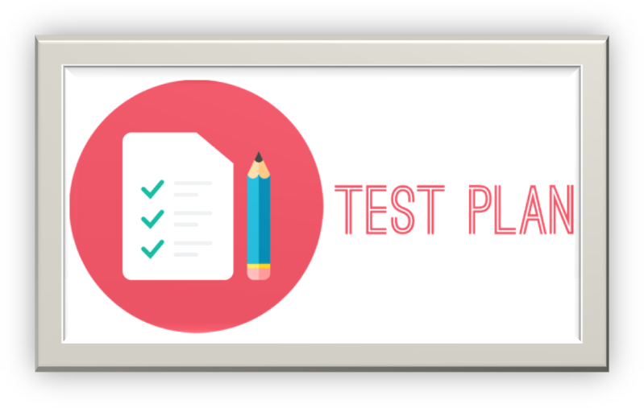

CONTENTS OF TEST PLAN (or) INDEX OF TEST PLAN:

  - Introduction
  - Objective.
  - Reference documents.
  - Test coverage
  - Features to be tested
  - Features not to be tested
  - Test strategy
  - Levels of testing
  - Types of testing
  - Test design technology
  - Configuration management
  - Test matrices
  - Terminology
  - Automation plan
  - List of automated tools
  - Base criteria
  - Acceptance criteria
  - Suspension criteria
5.0 Test deliverables
6.0 Test environment
7.0 Resource planning
8.0 Scheduling
9.0 Staffing and Training
10.0 Risk and Contingences.
11.0 Assumptions.
12.0 Approval information.

INTRODUCTION:

  - Objective: The purpose of the document will be described clearly in this section.
  - Reference documents: The list of all the documents (Project Plan) that are referred while preparing the test plan will be listed out here in this section.


2.0 TEST COVERAGE:

1.1 Features to be tested: The list of all the features within the scope to be tested will be listed out here in this section. Eg: GMAIL>>
Compose mail, Inbox, Sent items
  - Features not to be tested:
The list of all the features that are not planned for the testing will be listed out here in this section. EX:

    - Out of scope features.
    - Low risk features.
    - Features that are planned to incorporate in future.
    - Features that are skipped based on time constrains.

TEST STRATEGY:

It is an organizational level term which describes how to perform testing on all the projects in that organization.
Test plan: It is project level term which describes how to perform testing in a particular project in a detailed manner.

  - Levels of testing: The list of all the levels of testing that are maintained in that company will be listed out in this section. Eg: Unit level, Module, Integration, system and UAT

  - Types of testing:
The list of all the types of testing that are conducted in that company will be listed out here in this section. Ex: Build Acceptance Testing, Retesting etc.
  - Test design technique:
The list of all the techniques that are used in that company, while developing the test cases will be listed out in this section EX: BVA- Boundary Value Analysis, ECP- Equalance Class Partition.

  - Configuration management: To be discussed

Note: Metrics: Measurements.

  - Test metrics:
The list of metrics needs to be maintained in that company during the testing process will be maintained in this section Ex: Test case metrics, Defect metrics etc.

  - Terminology:
The list of all the terms along with their meaning’s that are used in that company will be maintained here in this section.


Ex: GUI/UI/COSMETIC etc.

Bug See Defect
Defect Software function does not work as per specification Defect
Owner The person who created the defect
Issue Software function does not work as expected or is not specified RDT Requirement Driven Testing
SDLC Software Development Life Cycle SME Subject Matter Expert
TDE Test Driven Environment UAT User Acceptance Testing

  - Automation plan: The list of all the areas that are planed for automation will be listed out here in this section.

  - Automated tools: The list of automated tools that are used in that company will be listed out in this section. Eg: LOAD RUNNER, JMeter, QTP, SELENIUM etc.
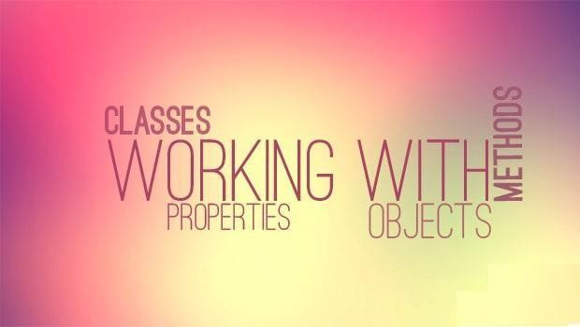

BASE CRIATERIA:

  - Acceptance criteria: When to stop testing will be clearly specified in this section. Eg: UAT

  - Suspension criteria: When to suspend the build will be clearly maintain in this section. Eg: Sanity testing
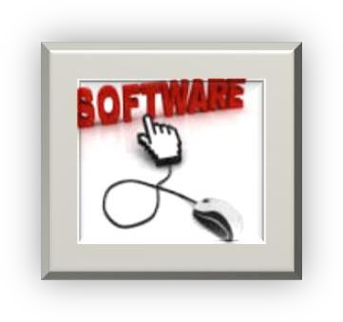

5.0 TEST DELEVERABELS:
The lists of all the documents that are to be prepared during testing process will be maintained

here in this section. Ex: CR’s,Test case document, Defect profile document etc.

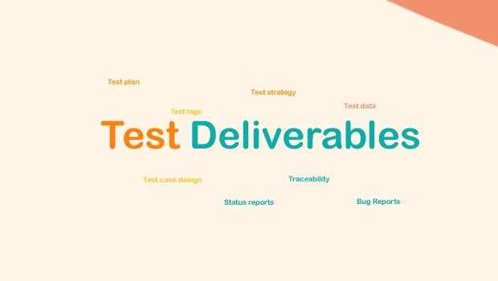

TEST ENVIRONMENT:

The clear details of the environment that is about to be used for testing the application will be clearly maintained in this section. Ex: Depending upon the Project the Environment will be selected.
    - STAND-ALONE ENVIRONMENT (OR) ONE-TIER ARCHITECTURE.
    - CLIENT-SERVER ENVIRONMENT (OR) TWO-TIER ARCHITECTURE.
    - WEB ENVIRONMENT (OR) THREE-TIER ARCHITECTURE.
    - DISTRIBUTED ENVIRONMENT (OR) N-TIER ARCHITECTURE.
- QA , Stage , UAT Environment


7.0 RESOURCE PLANING:

Who has to do what will be clearly planned and maintained in this section?



8.0 SCHEDULING:

The starting dates and ending dates of each and every list will be clearly planed and maintained here in this section.


9.0 STAFFING AND TRAINING (KTS-KNOWLEDGE TRANSFER SESSION’S):

To accomplish this project successfully any staff or training is required then that information will be clearly maintained in this section.


RISK & CONTINGENCIES:

The list of all the potential risks and corresponding plans will be maintained in this section.

RISKS:

    - Employees may leave the organization in the middle of the project.
    - Unable to deliver the project within the deadlines.
    - Customers imposed dead lines.
    - Unable to test all the features within the time.

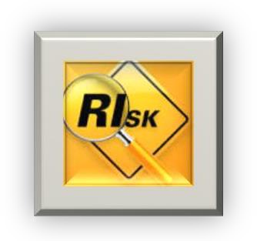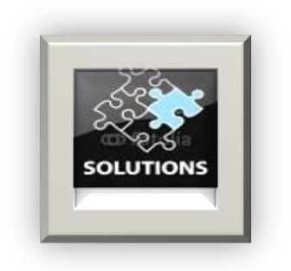

CONTINGENCIES (SOLUTION’S):

- Employees need to maintain on the bench.
- Proper plan groundwork.
- What to be skipped should be planned in case of customers imposed dead lines.
- Priority based execution.

11.0 ASSUMPTION:

The list of all the assumption’s need to be made by the testing people will be maintained here in this section.
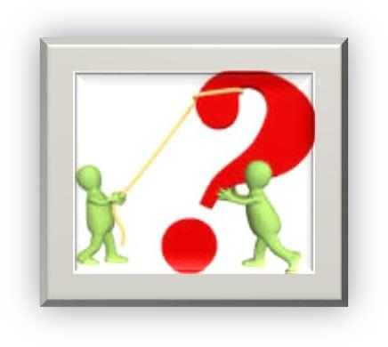


12.0 APPROVAL INFORMATION:

Who has approved this document, when it is approved will be maintained in this section. Ex: Test Manager/Project manager.

2. Test Development:

Requirement Document:

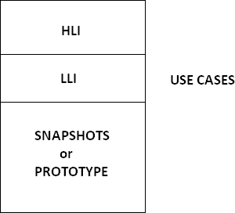

HLI-HIGH LEVEL INFORMATION, LLI-LOW LEVEL INFORMATION.

USE CASE: It describes the functionality of certain feature of an application in terms of actors, actions and responses.

Note: USECASE was prepared by Business Analyst (BA).

SNAPSHOT:
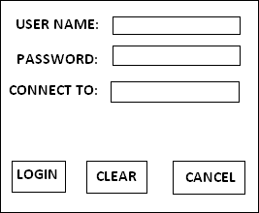

Functional Requirements:

- Login screen should contain USER NAME, PASSWORD, CONNECT TO Fields, LOGIN, CLEAR, CANCEL Buttons.
- Connect to field is not a mandatory field, but it should allow the user to select a database option, if required.
- Upon entering the user name, password and clicking on login button, the corresponding page must be displayed.
- Upon entering the information into any of the fields and clicking on clear button, all the fields must be cleared and the cursor must be available in the user name field.
- Upon clicking on cancel button, login screen must be closed.

Special Requirements:

- Upon invoking the application, login and clear buttons must be disable.
- Cancel button must be always enabled.
- Upon entering some information into any of the fields, the clear button must be enabled.
- Upon entering some information into username and password login button must be enabled.
- Tabbing order must be username, password, connect to, login, clear and cancel.

USE CASE TEMPLATE:

NAME OF THE USE CASE :
DESCRIPTION OF THE USE
CASE : ACTORS INVOLVED | :
SPECIAL REQUIREMENTS | :
PRE CONDITIONS | :
POST CONDITIONS | :
FLOW OF EVENTS | :
USE CASE DOCUMENT:
NAME OF THE USE CASE | : LOGIN USE CASE
DSCRIPTION OF THE USE CASE : THIS USE CASE DESCRIBES THE FUNCTIONALITY OF ALL THE FEATURES PRESENT IN THE LOGIN SCREEN.
ACTORS INVOLVED : NORMAL USER/ADMIN USER.

SPECIAL REQUIREMENTS :

There are 2 types of Special Requirements:

  - Implicit Requirements
  - Explicit Requirements

- Implicit Requirements: The requirements that are analyzed by the Business Analyst and his team, which will add some value to the application, and will not affect any of the customer’s requirement.
- Explicit Requirements: The requirements that are explicitly given by the customer are known as Explicit Requirements.

Explicit Requirements:

- Upon invoking the application, login and clear buttons must be disable.
- Cancel button must be always enabled.
- Upon entering some information into any of the fields, the clear button must be enabled.
- Upon entering some information into both the username and password fields’ login button must be enabled.
- Tabbing order must be username, password, connect to, login, clear, and cancel.

Implicit Requirements:

- Upon invoking the application the cursor must be available in the user name field.
- Upon entering invalid user name, valid password, and clicking on login button the following error msg must be displayed “INVALID USER NAME Please try again”.
- Upon entering valid user name, invalid password and clicking on login button the following error msg must be displayed “INVALID PASSWORD Please try again”.
- Upon entering invalid user name, invalid password and clicking on login button the following error msg must be displayed “INVALID USER NAME & INVALID PASSWORD Please try again”.

GENERIC REQUIREMENTS: Universal Requirements.

SPECIFIC REQUIREMENTS: Customer Requirements.

Pre Conditions : Login screen must be available.
Post Conditions : Either Home page or Admin page for valid users and error msg’s for invalid users.

Flow of Events:
Main Flow:
ACTION | REPONSE
*Actor invoke the application  *Actor enters valid user name, valid password and clicks on login button.  *Actor enters valid user name, valid password, selects a database option and clicks on login button.  *Actor enters invalid user name, valid password and clicks on login button.  *Actor enters valid user name, invalid password and clicks on login button.  *Actor enters invalid user name, invalid password and click on login button.  *Actor enters some information into any of the fields and click on clear button.  *Actor clicks on cancel button. | * Application displays the login screen with the following fields:  User name, password, connect to, login, clear, and cancel buttons.  *Authentication’s, application displays either home page depending upon the actor enter.  *Authenticates, application displays either admin page depending upon the actor enter with the mentioned database connection.  *Go to alternative flow table 1.  *Go to alternative flow table 2.  *Go to alternative flow table 3.  *Go to alternative flow table 4.  *Go to alternative flow table 5.

Alternative flow table 1 (INVALID USER NAME):

ACTION | RESPONSE
*Actor enters invalid user name, valid password and clicks on login button. | *Authenticates, application displays the following error msg: “INVALID USER NAME Please try again”.

Alternative flow table 2 (INVALID PASSWORD):

ACTION | RESPONSE
*Actor enters valid user name, invalid password and clicks on login button. | *Authenticates, application displays the following error msg: “INVALID PASSWORD Please try again”.

Alternative flow table 3 (INVALID USER NAME & PASSWORD):

ACTION | RESPONSE
*Actor enters invalid user name, invalid password and clicks on login button. | *Authenticates, application displays the following error msg: “INVALID USER NAME & PASSWORD Please try  again”.
Alternative flow table 4 (CLEAR CLICK):

ACTION | RESPONSE
*Actor enters some information in any of the fields and clicks on clear button. | *Application clears the fields and makes the cursor available in the user name.

Alternative flow table 5 (CANCEL CLICK):

ACTION | RESPONSE
*Actor clicks on cancel button. | *Login screen is closed”.

Functional Point:

The point at which the user can perform some action can be considered as Functional Point.

Test Scenario: The situation where we can do testing.

There are 3 types of flow:

- Main flow : Main page/Home Page.
- Alternative flow : Error msgs page.
- Exceptional flow : Server problems/Network problems.

TRACEABILITY MATRIX:

It is a document which contains a table of linking information used for tracing back for the reference.
In any kind of confusion or questionable situation.

Note: Matrix: Combining different points in a document.

REQUIREMENT TRACEABILITY MATRIX: (RTM)

RTM:

TEST CASE ID | REQUIREMENT ID
1  2  3  4  5  6 | 1.0  1.0  1.1  1.2  1.2  2.0

Note: The Test cases which are prepared related to which requirement is mentioned here in this table. If we mention Req. Id in the test case document, it same as the RTM, so we need not to maintain RTM separately for the application.

DEFECT TRACEABILITY MATRIX : (DTM)

DTM:

DEFECT ID | TEST CASE ID
1  2  3  4 | 23  34  56  44

Note: The defects which are related to which test case is mentioned here in this table.

TYPES / Category OF TEST CASES:

TEST CASES are broadly divided into 3 types:

GUI TEST CASES FUNCTIONAL TEST CASES
  - POSITIVE TEST CASES
  - NEGATIVE TEST CASES

NON FUNCTIONAL TEST CASES

TEMPLATE:

PROJEC T NAME: MODUL E:
AUTHO R:
REQ. ID | TEST CA SE ID | CATEG ORY | PREREQ UISITE | DESCRIPTION/ TEST STEPS | EXPECTED VALUE | TE ST DA TA | ACTUAL VALUE | RESU LT (PASS  /FAIL  )  Unabl  e to test | BU ILD  No  . | Defec t ID
x
x

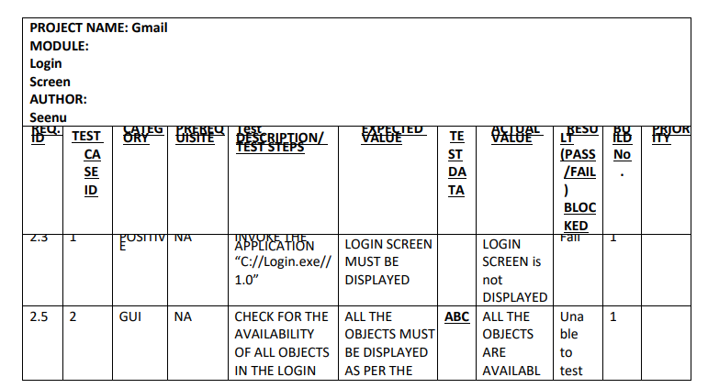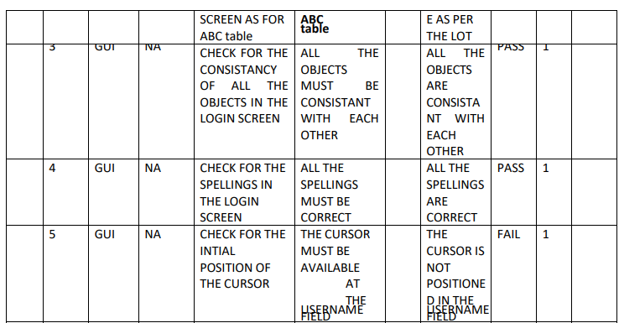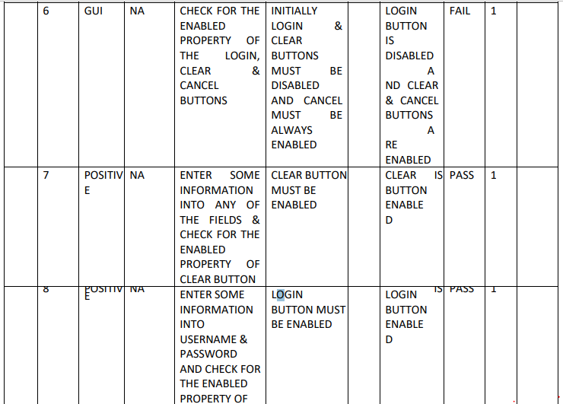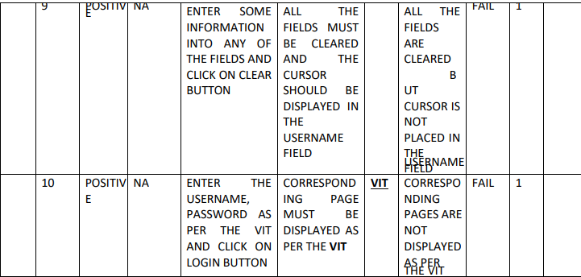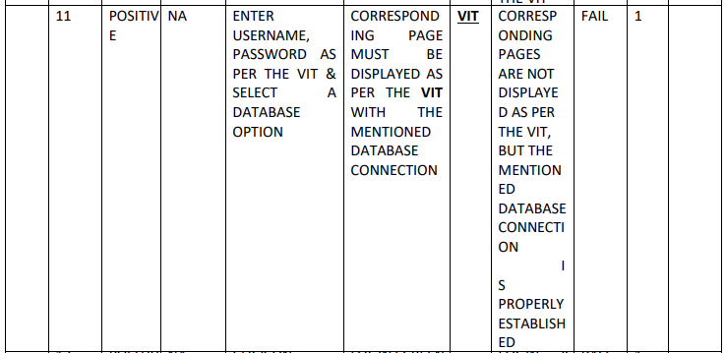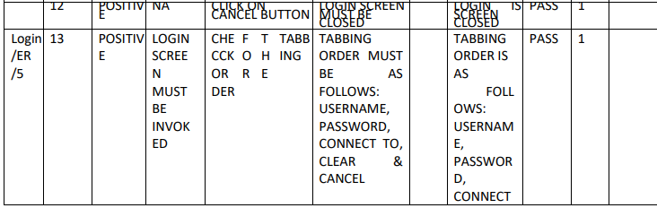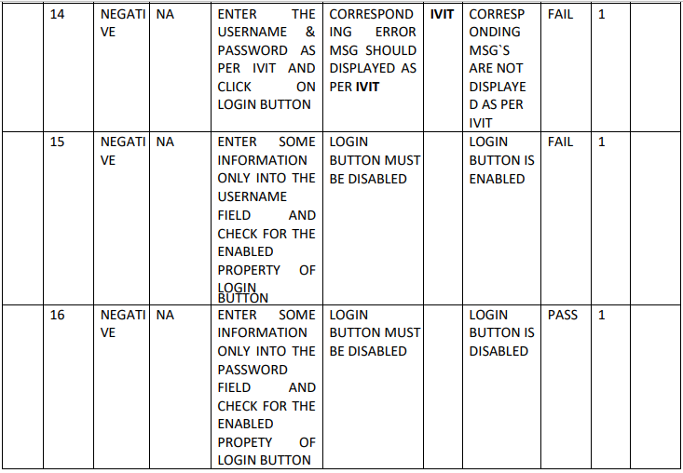

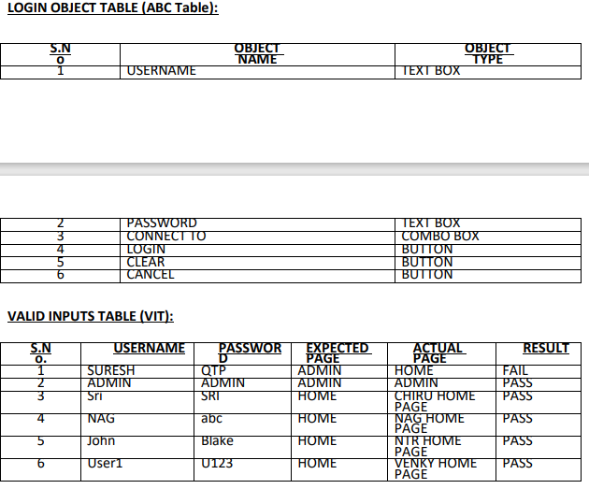
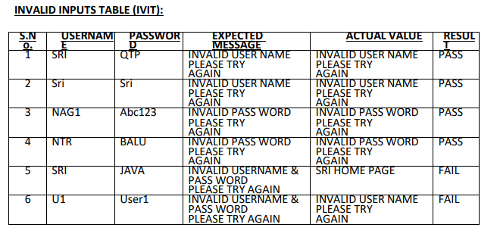

TEST DESIGN TECHNIQUES (or) INPUT DESIGN TECHNIQUES :

- Boundary Value Analysis BVA( Range / Size ):
Boundary value analysis is a software testing technique in which tests are designed to include representatives of boundary
values.

Min | PASS
Min-1 | FAIL
Min+1 | PASS
Max | PASS

Max-1 | PASS
Max+1 | FAIL

- Equivalence Class Partitions ECP (Type):
The technique is to divide (i.e. to partition) a set of test conditions into groups or sets that can be considered the same (i.e. the system should handle them equivalently), hence ‘equivalence partitioning’. Equivalence partitions are also known as equivalence classes – the two terms mean exactly the same thing.

Or
Equivalence partitioning (also called Equivalence Class Partitioning or ECP[1]) is a software testing technique that divides the input data of a software unit into partitions of equivalent data from which test cases can be derived.

VALID | INVALID
Pass | Fail

Ex:
A login process allows user ID and Password to validate users. User ID allows Alpha Numeric’s in lower
case from 4 to 16 characters long. Password allows alphabets in lower case 4 to 8 characters long. Prepare BVA and ECP for user ID and password.

USER ID
BVA ECP
4 --- PASS
VALID | INVALID
a to z 0 to 9 | A to Z  Special characters Blank space

3 --- FAIL
5 --- PASS
16 -- PASS
15 -- PASS
17 -- FAIL

PASSWORD
BVA ECP
4 -- PASS
VALID | INVALID
a to z | A to Z 0 to 9  Special characters  Blank space

3 -- FAIL
5 -- PASS
8 -- PASS
7 -- PASS
9 -- FAIL

3. TEST EXECUTION:

In this phase the test engineer will do the following:

- QA will perform the action as it is described in the testcase description column.
- They will observe the actual behavior of the application.
- They will write the observed value in the actual value column.

RESULT ANALYSIS:

In this phase the test engineer will compare the actual value with the expected value. If both are matching, then QA will decide the result as PASS otherwise FAIL.

Note: If at all the Test case is not executed in any reason, then the test engineer will specify BLOCKED/unable to test in the result column.

Ex: If application has 5 pages, in each page a next button will be available, when we click on next button, we will enter into next page, if next page button of 4th page is not working, we can’t enter into 5th page and all the test cases related to that 5th page can’t test. The result to all that test cases will be BLOCKED.

BUG TRACKING:

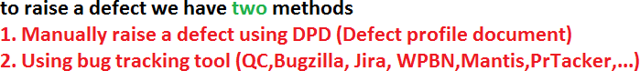
It is a process of identifying, isolating and managing the defects.

DEFECT ID: The sequence of defect no’s will be mentioned here in this section.

TEST CASE ID: The test case id based on which defect is found will be mentioned here in this section.

ISSUE DISCRIPTION: What exactly the defect is will be clearly described here in this section.

REPRODUCABLE DEFECTS: The list of all the steps followed by the test engineer, to identify the defects will be listed out here in this section.

DETECTED BY: The name of the test engineer, who has identified will be mentioned here in this section.

DETECTED DATE: The date on which the defect is identified will be mentioned here in this

section. DETECTED BUILD: The build number in which the defect is identified will be

mentioned here in this section. DETECTED VERSION: The version number in which defect

is identified will be mentioned here in this section. VERSION: On which version the build

was released will be mentioned here in this section.

DEFECT SIVIORITY: Severity describes the seriousness of the

application. SEVERITY is classified into 4 types:

1. | Critical/Show stopper | SIVI 1 | S1 | 1
2. | MAJOR | SIVI 2 | S2 | 2
3. | MINOR | SIVI3 | S3 | 3
4. | SUGGESTION | SIVI4 | S4 | 4

- Critical DEFECTS / S1 : If at all the problems are related to the navigational or unavailability of main functionality then such type of defects are treated as FATAL DEFECTS/ Critical/Show stopper/Blocker

Ex:
PAGE1 PAGE2 PAGE3 X.
No navigation for next page.
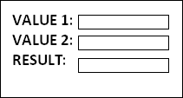

ADD button is missing.

- MAJOR DEFECTS / S2 : If at all the problems are related to not working of the main functionality then such types of defects are treated as MAJOR DEFECTS.

Ex:
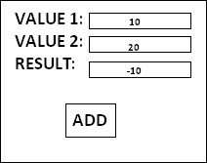

Instead of 30 the result is -10.

- MINOR DEFECTS / S3 : If at all the problems are related to look and feel of the application, then such type of defects are treated as MINOR DEFECTS.

Ex:
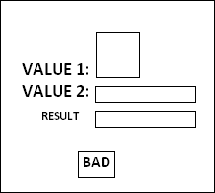

Instead of ADD button BAD button, and Text boxes size and Value names are not consistent with each other.

- SUGGESTIONS / s4 : If at all the problems are related to value (User friendliness) of the application then such type of problems are treated as SUGGESTIONS.

Ex:

INVALID USERNAME PLEASE TRY AGAIN

POOR HELP

PLEASE ENTER 5 ALPHANUMERIC ONLY

STRONG HELP

TOOL TIPS MUST BE HELPFUL.

DEFECT PRIORITY: It describes the sequence in which, the defects need to be rectify / Impact of the functionality PRIORITY is classified into 4 types:

1. | CRITICAL | PRI 1 | P1 | 1
2. | HIGH | PRI 2 | P2 | 2
3. | MEDIUM | PRI 3 | P3 | 3
4. | LOW | PRI 4 | P4 | 4

Usually:

SIVIORIT Y | PRIORITY
critical DEFECTS | CRITICAL
MAJOR DEFECTS | HIGH
MINOR DEFECTS | MEDIUM
SUGGESTIONS | LOW

Sometimes highest severity defects will be given least priority and sometimes least severity defects will be given highest
priority.

BUG LIFE CYCLE:
HOLD
REJECTED
AS PER
DESIGN
IS IT
REALLY A
DEFECT
OPEN
FIXED
NEW
IF
DEFECT
REOPEN
IS DEFECT
REALLY
RECTIFIED
CLOSED
BUILD # 1
APPLICATION
NO
YES
NO
STOP THE TESTING
NO
YES
BUILD # 2
TESTING
RECTIFICATION
DEVELOPMENT
YES
REQUIREMENTS

NEW: whenever the defect is newly identified by the tester, he will set the status as new.

OPEN: Whenever the developer accepts the defects then he will set the status as open.

DEFERRED: whenever the developer accept the defects and wants to rectify it in later then he will set the status as deferred.

FIXED: Once the defect is rectified then the developer will set the status as fixed, it is also called as rectified.

REOPEN & CLOSED: Once the next build is released the tester will check whether the defect is really rectified or not, if at all the defect is really rectified, then he will set the status as closed, otherwise reopen.

HOLD: Whenever the developer is confused to accept or reject, then he will set the status as hold.

Whenever the defect is in hold status there will be a meeting on that defect and if it is decided as a defect, then the developers will set the status as open otherwise the testers will close it.

REJECTED: Whenever the developers feel that, it is not at all a defect, then they will set the status as rejected.

Whenever the defect is rejected, then the test engineers will once again check it, if at all they also feel it is not a defect then they will set the status as closed otherwise reopen.

AS PER DESIGN: This situation really occurs. Whenever developers feel the testers are not aware of latest requirements then they will set the status as as per design.

Whenever the defect is as per design status the testers will once again check it by going through the latest requirements, if at all they also feel it is as per design then they will set the status as closed otherwise reopen.

6. REPORTING:

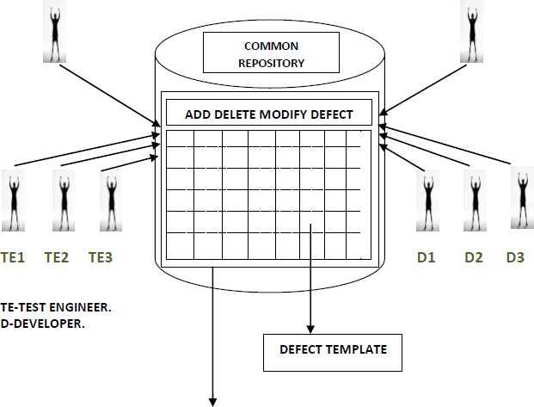

https://docs.google.com/document/d/1d4mnV5BwL1zlW_iJqKJFbzYMqglDNg9U/edit?usp=sharing&ouid=107220232723817776659&rtpof=true&sd=true

BUG TRACKING TOOL: It is a software application which can be access only by the authorized people and provides all the facilities for bug tracking and reporting.

Ex: BUGZILLA, PR TRACKER, ISSUE
TRACKER,WPBN,QC,JIRA…..etc. PR-PERFORMANCE REPORTER.

Ex:
No Transparency: Test engineer can’t see what was happening in the development deportment and developer can’t look what was the process is going in the testing deportment.

Redundancy: There is a chance that some defect will be found by all the test engineers.
Ex: Suppose all the test engineers found the defect of the login screen login button, and then they raise the same as a defect.

BUG TRACKING TOOL ORIENTED BUG REPORTING PROCESS:
The test engineer enter into bug tracking tool, he add defect to the template with add defect feature and writes the defect in corresponding columns, the test lead parallel observes it by bug tracking tool, and he assign severity.
The development lead also enters into the bug tracking tool. He assigns the priority and task to the developer. The developer enters into the tool and understands the defect and rectifies it.
Tool: Something that is use to complete the work easily and perfectly.
Note: Some companies’ use their own Bug Tracking Tool, this tool is developed by their own language, this tool is called ‘INHOUSE TOOLS’.
TEST CLOSURE ACTIVITY: This is the final activity in the testing process done by the test lead, where he will prepare the test summary report, which contains the information like:
Number of cycles of execution,
Number of test cases executed in each cycle, Number of defects found in each cycle, Defect ratio and etc.
defects / Person-Day)

